**ST. XAVIER’S COLLEGE**

**(Affiliated to Tribhuvan University)**

Maitighar, Kathmandu



**COMPUTER GRAPHICS**

**Lab Assignment #1**

**Submitted by:**

Sneha Prasai

013BSCCSIT040

**Submitted to:**

|  |  |
| --- | --- |
| **Er. Anil Sah**  **(Lecturer)** |  |
| **Department of Computer Science** | |

**STATEMENT:**

DRAW THE CHECKBOX.

**PROGRAM CODE:**

//---------------------------------------------------------------------------

#include <vcl\vcl.h>

#pragma hdrstop

#include "Unit1.h"

//---------------------------------------------------------------------------

#pragma resource "*.dfm"

TForm1 *Form1;

//---------------------------------------------------------------------------

__fastcall TForm1::TForm1(TComponent* Owner)

: TForm(Owner)

{

}

//---------------------------------------------------------------------------

void __fastcall TForm1::Button1Click(TObject *Sender)

{

Form1->Canvas->Pen->Width=3;

Form1->Canvas->Rectangle(10,10,250,200);

Form1->Canvas->MoveTo(10,10);

Form1->Canvas->LineTo(250,200);

Form1->Canvas->MoveTo(10,200);

Form1->Canvas->LineTo(250,10);

Form1->Canvas->MoveTo(10,105);

Form1->Canvas->LineTo(250,105);

Form1->Canvas->MoveTo(130,10);

Form1->Canvas->LineTo(130,200);

Form1->Canvas->MoveTo(70,10);

Form1->Canvas->LineTo(70,200);

Form1->Canvas->MoveTo(190,10);

Form1->Canvas->LineTo(190,200);

Form1->Canvas->MoveTo(10,57);

Form1->Canvas->LineTo(250,57);

Form1->Canvas->MoveTo(10,152);

Form1->Canvas->LineTo(250,152);

}

//---------------------------------------------------------------------------

**OUTPUT:**

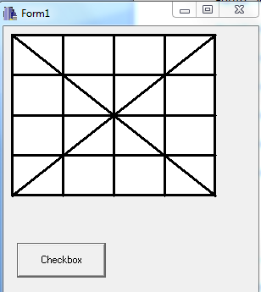

**CONCLUSION:**

Therefore, the checkbox can be drawn using c++ builder easily and systematically.

**REFRENCE:**

[1] Computer Graphics, Intro To Builder.ppt.